Respondus Help Guide
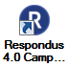
Respondus can be used to build and manage tests/pools. You can import questions (using the Respondus format) from a Word document or text file and then export those to Blackboard as a test or pool.
To familiarize you with the tool, the Respondus icon is pictured right and looks like a blue circle with a white R in it.
Note: If you haven’t already installed Respondus, it can be downloaded from the Online Instructional Resources course in Blackboard > Course Content > Helpful Tools > Respondus Products folder. The installation information and password are provided there.
This guide includes the following information. Click an item to advance to that section.

Question Format for Import 2
File Setup 2
Question Format 2
Examples and Other Options 2
Sample Files for Import 5
Import Questions 5
Publish to Blackboard 6
Need Help? 7

Question Format for Import
For complete details on formatting questions and including images, open Respondus and go to the Help menu at the top > Help Topics. Then switch to the Index tab on the left, scroll down to the bottom, and select Standard Format for Importing Questions.

File Setup
- You can use a plain text file (.txt) or a Word document (.docx or .doc).
- The Word document can contain images, bolding, and italics.
- Do not include any extra information in the document (i.e., remove headings, blanks for names, miscellaneous text from the publisher, instructions for taking the test, etc.).

Question Format
- Question numbers need to be sequential starting with number 1.
- The question number is followed by either a period . or a closing parenthesis ) followed by one space and then the question text.
- Multiple-choice questions are then followed by the answer options a-t (or A-T), which are also followed by either a period or a closing parenthesis.
- The correct answer is indicated by an asterisk in front of the letter. Alternatively, you can provide an answer key at the end.

Examples and Other Options
The examples below are indented so they stand out. You would not indent them in your file.
1. Your question text for multiple choice and true/false.
a. possible answer
b. possible answer
*c. correct answer indicated by asterisk before the letter
d. possible answer

2) The question format for true/false is the same as multiple choice. Your questions can wrap onto multiple lines and can also include images (in Word documents, not text files).
a) True
*b) False
Point Value: Optionally, you can specify a point value. On the line above the question text (and question type indicator), add “Points: 1” (replacing “1” with whatever the point value is). That point value will apply to all questions after it until a new point value is defined.
Points: 1
3. True/false can also be written with just the letter as the option.
*a. T
b. F
Feedback: Optionally, you can add correct and incorrect feedback for students using ~ and @ respectively. Make sure your test settings in Blackboard display the feedback to students.
4. Question text goes here.
~ Correct answer feedback follows a tilde.
@ Incorrect answer feedback follows the at symbol.
a. possible answer
b. possible answer
c. possible answer
*d. correct answer
e. possible answer
Other Question Types: For any question other than multiple-choice and true/false, you need to specify which type of question it is above the question text using “Type: ” followed by the letter(s). Each question needs the type specified unless it is multiple-choice or true/false.
Essays: Optionally, you can include the correct answer that will be displayed to you as you grade. Remember, each question needs the type specified.
Type: E
5. Question/instructions for an essay.
a. Optionally, this is the answer that will be visible to you as you grade. Notice there is not an asterisk in front of the “a.” You will need to manually grade essays.

Type: E
6. Question/instructions for another essay.
Fill-in-the-Blank: For fill-in-the-blank questions, you’ll want to account for spelling variations and any alternatives you will accept (e.g., with or without a hyphen, abbreviations, etc.). Include the correct answer(s) after the question.
Type: F
7. This is a fill-in-the-_____. By default, answer options are not case sensitive.
a. blank
b. blank question
Matching: The question & answer pairs are correct matches, separated by an equal = sign. In Blackboard you can display answers randomly or manually mix them. If you’re using an answer key, you would skip the number for the matching question(s) in the key.
Type: MT
8. Match the definition to the term (or whatever your instructions are).
a. Definition/question one is written = Term/answer One
b. Definition/question two is written = Term/answer Two
c. Definition/question three is written = Term/answer Three
Headings or Reused Information: You cannot make headings in Blackboard tests, so any information that needs to be used to answer multiple questions should be repeated in each of those questions, especially if you are building a question pool, plan to randomize questions, display them one at a time, etc.
9. Read Case 1.1 below and then answer the question that follows.
Case 1.1: Lorem ipsum dolor sit amet, sed do eiusmod tempor incididunt ut labore et dolore magna aliqua. Ut enim ad minim veniam, quis nostrud exercitation ullamco laboris nisi.
You would then include the actual question/prompt, bolded to stand out. Bold and italics will be retained.
a. something wrong
*b. something right
c. something wrong
d. something wrong

10. Case 1.1: Lorem ipsum dolor sit amet, sed do eiusmod tempor incididunt ut labore et dolore magna aliqua. Ut enim ad minim veniam, quis nostrud exercitation ullamco laboris nisi.
A different question/prompt, with a different correct answer.
a. something wrong
b. something wrong
*c. something right
d. something wrong
Answer Key: If the asterisks hadn’t been used above to indicate the correct answer, the answers would go in an answer key at the very end, after all the questions. Use either the asterisk or “Answers:” list at the end to indicate correct answers, not both. As noted earlier, the matching question(s) is skipped in the answer key.
Answers:
1. c
2. b
3. T
4. d
5. Essay answer text visible to you for grading.
6. Essay answer text visible to you for grading.
7. blank
7. blank question
9. b
10. c
If you would like to import other question types, such as Fill in Multiple Blanks, Ordering, Multiple Answer, etc., please open Respondus and go to the Help menu at the top > Help Topics. Then switch to the Index tab on the left, scroll down to the bottom, and select Standard Format for Importing Questions.

Sample Files for Import
You can download and use the following files to try importing. Right-click on the text file links and choose “Save Link As” to save them, otherwise they may open in your browser.
- Sample Word file
- Sample Word file with answer key
- Sample text file
- Sample text file with answer key

Import Questions
After you have your questions formatted properly, you can import them into Respondus.
- Open Respondus.
- At the top of the Start tab, make sure the “Current Personality” is set to Blackboard.
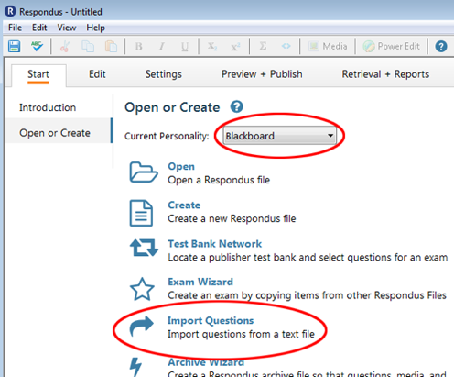
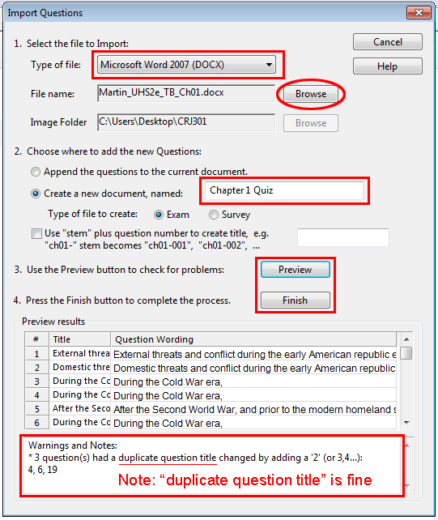
- Click Import Questions.
  - Click the Type of file drop-down menu and select the one that matches your file (e.g., “Microsoft Word 2007 (DOCX)” if the file extension is .docx).
  - Click the Browse button for “File name” to browse and select the appropriate file.
  - In step 2, type a name for the new Respondus file. You may want to put the course name at the beginning (i.e., “CRJ301 Chapter 1 Quiz”) so you can easily tell them apart.
  - Click the Preview button in step 3. If you get any error other than “duplicate question title changed,” stop what you’re doing, fix the error(s) in the original file, and Preview again before continuing (e.g., question type is wrong/missing, answer is missing).
  - Click the Finish button in step 4.
- Click OK.
You will then be taken to the Edit tab and can make adjustments if needed. In the Settings tab you can optionally adjust the settings that you want for the test in Blackboard, or you can skip that and adjust it yourself in Blackboard.

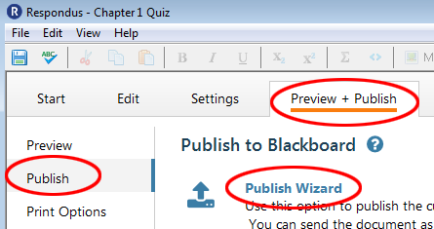
Publish to Blackboard
- Click the Preview + Publish tab at the top and then click Publish on the left.
- Click Publish Wizard.
- In the window that pops up, leave step 1 with the default “Publish to single course,” unless you need to publish the same test to multiple courses.
- For step 2, click the Blackboard Server drop-down menu and select add new server. (Note: If you already have the Blackboard Server set up and working properly, select that server and skip to the “Publish to the Course(s)” section below.)
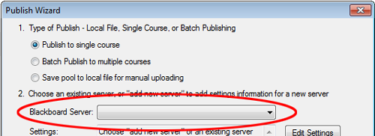

Server Setup Option 1: Preconfigured Settings
- In the Add New Server Settings window, choose Yes, check for preconfigured server settings and click Next.
- For step 1, type in your name or something like “Blackboard Upload.”
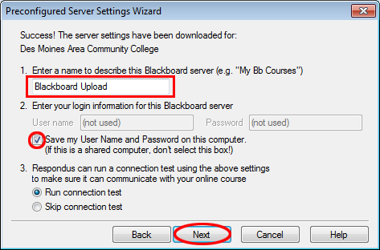
- For step 2, select the option to Save my User Name and Password… and click Next.
- A pop-up window will appear asking you to log into Blackboard using the browser provided by Respondus. If that browser does not open, click OK and it should pop up.
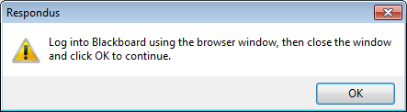
- In the Respondus browser, click OK to accept cookies. Then enter your DMACC username and password (your username only, not your full email address) and click the Sign In button.
- After you are logged in, click the Close After Login button in the upper-right corner and then click OK.
- You will see a “Connection Test: Completed Successfully” status. Click Next and then click Finish. Proceed to the “Publish to the Course(s)” section below.

Server Setup Option 2: Manually Configure
If the preconfigured server settings cannot be found, you can configure them manually.
- In the Add New Server Settings window, choose No, I want to enter the server settings manually and click Next. The Blackboard Server and Course window will appear.
  - For step 1, you need the login URL (hyperlink) for Blackboard.
    - Open your browser and navigate to Blackboard (dmacc.blackboard.com). Do not log in. If you are already logged in, you need to log out.
    - Copy the full URL in the address bar at the top of the browser.
    - Paste that URL into the step 1 box in Respondus.
  - For step 2, switch back to your browser and log into Blackboard with your DMACC username and password. Go into a course where you are the instructor.
    - Copy the full URL in the address bar at the top of the browser.
    - Paste that URL into the step 2 box in Respondus.
  - Click the Extract button in step 3. Do not adjust anything in the boxes for step 3.
  - For the Description, type in your name or something like “Blackboard Upload.”
  - Then type in your DMACC username (your username only, not your full email address) and password.
  - Click the checkbox to Remember my User Name and Password… so you don’t have to type it in every time.
  - Click OK.

Publish to the Course(s)
- Whatever you typed for the “Description” of the server will be selected in the Blackboard Server drop-down menu. If you used the Preconfigured Server Settings, “[PSS]” will be added to the description you entered. Click the Next button.
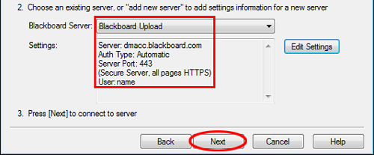
  - If you manually configured the server and receive an error message about failing to connect, click Edit Settings and make sure your username and password are correct. Then click Next.
  - Note: If you change your DMACC password, don’t forget to update it in the Respondus server settings.
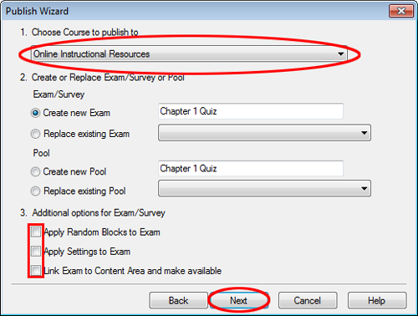
- In the Publish Wizard window, click the drop-down menu in step 1 and select the course where you want the test.
- For step 2, adjust the test name as needed. If you would prefer a pool of questions, you can switch to “Create new Pool.”
- For step 3, deselect all the options. Click Next.
  - This will put the test in your Blackboard course in Course Tools > Tests, Surveys, and Pools > Tests (or Pools if you selected to create a new Pool). Then you can deploy the test in Course Content when you are ready (from Assessments > Test) and adjust the settings.
  - Alternatively, if you used the Settings tab in Respondus, deselect only the “Apply Random Blocks to Exam” option. Click Next. You will then need to select where in Course Content you want to deploy the test and click Next.
- After the test/pool is successfully imported, click Finish.

Need Help?
Contact one of our instructional designers.

